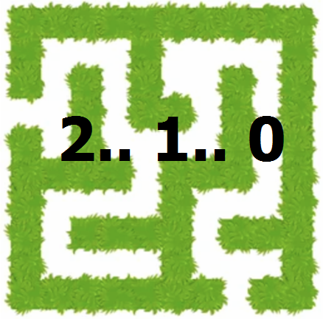
Code / Project : CME1251 / 2
Year / Semester : 2023-2024 Fall Semester
Duration : 6 weeks

Project: Countdown

The aim of the project is to develop a maze game,
in which treasures/numbers are collected while walking in it.

General Information

The game is played in a 23*53 game field including outer walls. Game characters are P and numbers. Human player is represented by P. Computer controls the numbers. The aim of the game is reaching the highest score.

Game Characters

P: Human player

- Cursor keys: To move the human player (4 directions)

- Human player can move in empty spaces, push number(s) or smash a number.

- At the beginning, human player has 5 lives.

Numbers: 9, 8, 7, 6, 5, 4, 3, 2, 1, 0

- These can be collected by the human player by smashing them.
  - 0 : 20 points.
  - 1, 2, 3, 4 : 2 points.
  - 5, 6, 7, 8, 9 : 1 point.

- Only number 0 is alive and moves randomly in four directions. Other numbers are static.

#####################################################
# 6 9 0 # Time : 0
# 3 ########### 6 # 64 #
# ### 0 6 # #4 5 # Life : 5
# 2 2 # # # 4 3 00 #
# 5 ### # # ### 8 # Score : 0
#0 ####### # # 6 7#
# # # ### 7 # #
# P 20# #4 # 5 2 # #
#4 ########### # # # ####### # #
# # # # 9 #
# # # 1### ### 0 #
# 6 5 5 2 # # 3 # #
# 8 8 6 49 # 1 2 2 # #
# 9 # # 4 4 # #
# # 3 8# 8### #
# # ### # 9 # #
# 3# # # 4 # 8 # #
# 6 19# ### # # # # # 4 3# # 7 #
# 1# 53 # # # # ### # #
# # # 2 6 8 # 9 # #
# 8 8 2 #
#####################################################

Game Initialization

- Walls
  - The inner walls in the game area are generated in random places.
  - There are 3 types of inner walls. The number of walls in the game area;
    - 3 * Long wall (length:11). It can be horizontal or vertical.
    - 5 * Medium wall (length:7). It can be horizontal or vertical.
    - 20 * Short wall (length:3). It can be horizontal or vertical.
  - Wall placement is random, but there must be at least 1 square (for 8 directions) among them. Walls cannot touch other walls.

- Human player P is located randomly.

- 70 numbers (0, 1, 2, 3, 4, 5, 6, 7, 8 or 9 with equal probability) are placed at random positions.

Game Playing Information

- Displayed time unit of the game is approx. 1 second.

- There can be only 1 game object (characters, items or walls) in a game square.

- Number 0: In 1 time unit (in 1 second); each "number 0" can move one square with random direction. If a "number 0" reaches the square of P, the player loses 1 life. If the player loses all lives, the game is over.

- Countdown action is done for every 15 seconds.
  - Number 2,3,4,5,6,7,8,9: Their values are decreased by 1.
  - Number 1: With the probability of 3%, number 1 is converted into number 0. So, it becomes alive.

- Human Player: P is much faster than number 0 (approx. 20 times faster (50 ms for each move)).

  - P can move around in empty spaces.

  - Pushing: P can push non-increasing number sequences, if there is an empty square behind the last number.
    - -> P65543100 (P can push this sequence to the right)
    - -> P544336 (P cannot push this sequence to the right)
    - -> P84621 (P cannot push this sequence to the right)

  - Smashing: P can smash the last number when pushing non-increasing number sequences, if there is a wall behind the last number. P cannot smash the number in the neighboring square. Non-pushable sequences are also non-smashable.
    - -> P6510# (P can smash 0 by pushing to the right)
    - -> P651# (P can smash 1 by pushing to the right)
    - -> P65# (P can smash 5 by pushing to the right)
    - -> P6# (P cannot smash 6, because it is neighbor to P)

  - For each smashed number, a new random number (5, 6, 7, 8 or 9 with equal probability) is generated in a random place.

Suggested Weekly Program

1. Discussing and designing solution alternatives. Creating the necessary variables, structures. Screen.
Planning task distribution and scheduling.
2. Human player (P) movements in empty squares. Timing.
3. Random generation of inner walls.
4. Generation of 70 numbers (0-9). Number 0 movements. Same square encounters (P and 0).
5. Pushing. Smashing. Regeneration of smashed numbers. Scoring.
6. Countdown action. Remaining parts of the game. Testing/Debugging.

First Evaluation: 22.12.2023  Report: 22.12.2023 | Final Evaluation: 5.1.2024 (powerpoint presentation + project web page)  Report: 5.1.2024

